Exercise - Ex-ante Gender Impact Assessment

Instructions:
In groups, please:
- Complete Sections 1.e) to 4 of the “Template - Ex-ante Gender Impact Assessment” for a proposed program titled “Managerial Training for Strengthening the Environmental Sustainability of Agriculture Production”.
  - Most of Section 1 has been completed and provides you with the basic parameters of the hypothetical proposed program. You will need to complete 1.e) and 1.f).
  - To help you complete Sections 2-4, please refer to the Annex for key statistics (Figure 1-4) and gender inequalities for Country X (Table 1).

- If there is time, discuss the questions listed after the template.

- Select a speaker from the group for a short debrief at the end.

This training material is the property of the International Monetary Fund (IMF) and is intended for use in IMF courses. Any reuse requires the permission of the IMF.

Template - Ex-ante Gender Impact Assessment (to be completed)
Ex-ante GIA Steps and Questions |  | Responses
  1: General Information and Target Group | - Proposed budget measure: | Managerial Training for Strengthening the Environmental Sustainability of Agriculture Production
 | - Lead Department: | The Ministry of Agriculture, Forestry and Fisheries (MAFF)
 | - Requested Resources (Appropriations): | 2 million $ over 5 years.
 | - Description of the Proposal: | Objective: This program will be a five-day training course run twice a year to train farm managers on techniques and practices for sustainable food processing and storage. In the long term, because of this program, it is expected that the agriculture industry will increase productivity and improve resilience to future climate related shocks.  Background: The Ministry of Agriculture, Forestry and Fisheries (MAFF) has recently introduced the Agricultural Extension Policy to ensure that farmers and their communities are able to acquire better agricultural knowledge/skill and technology. Managerial Training on Strengthening the Environmental Sustainability of Agriculture Production is a proposed program under this policy.
 | - Does this budget measure directly or indirectly affect people? If yes, continue with the rest of the assessment, if no explain why.
 | - Who or what is the target group?

  2: Expected Impacts  Please use disaggregated data from Figure 1-4 and knowledge of gender inequalities in Country X (Table 1) to complete these questions. | - Direct beneficiaries:  Who is expected to receive the direct benefits of this program? What is the gender composition/ratio of this group? Select one and explain.  Hint: what is the gender breakdown of farm managers (Figure 1-3)? | ☐ Predominantly Women or girls (≥80%)  ☐ Women or girls (60%-79%)  ☐ Gender balanced.  ☐ Men or boys (60%-79%)  ☐ Predominantly Men or boys (≥80%)  Please explain:
 | - Indirect beneficiaries:  Who is expected to receive indirect benefits of this program? What is the gender composition/ratio of this group? For example, those providing the service (Figure 4). | ☐ Predominantly Women (≥80%)  ☐ Women (60%-79%)  ☐ Gender balanced  ☐ Men (60%-79%)  ☐ Predominantly Men (≥80%)  or  ☐ No Indirect Benefits  Please explain:
 | - Are the benefits of the program expected to be equally distributed between men and women? If not, then why is that?  What is causing this difference? Please refer to Table 1 to help answer. | Please explain:
- Based on 2 c), is this program unintentionally perpetuating an existing gender inequality?
If something is preventing one gender from receiving the benefits of, or participating in, the program then the program could be unintentionally perpetuating an existing gender inequality. See Table 1 to help answer.
 | - Based on this assessment, what is the expected impact on gender equality? | ☐ Expected to advance a national gender equality goal  ☐ Expected to perpetuate an existing gender inequality  ☐ Expected to negatively affect gender equality  ☐ No impact  Please explain:
  3: Actions to address disproportionate impacts to advance gender equality. | - Based on the findings from Section 2, can the program be designed in a way to increase the representation or participation of women or men?  Are there alternative activities proposed or already in place which are addressing the inequality identified | Please explain:
  4: Plan for monitoring impacts | How will the actual impacts of the program be measured and monitored?  Which indicators will be assessed? How will the data be collected? If data isn’t currently disaggregated by sex then what resources are being set aside to collect sex-disaggregated data? | Please explain:

Discussion questions based on the results of this analysis:
- Is uptake of this program expected to be equal between men and women? If not, what do you think are the causes of this?

- Could specific adjustments be made to the program’s proposed approach to promote greater gender equality? Could targets be set? Could something be added?

- Does your country have similar gender gaps? If so, does your country have programs in place that are working towards closing the gender gaps identified in this analysis?

- Is there gender disaggregated data that is missing and would help improve this analysis?

Annex: Country X – Statistics and Key Gender Inequalities to Guide the Analysis
Figure 1: Employed Population, by Industry and Sex (%)
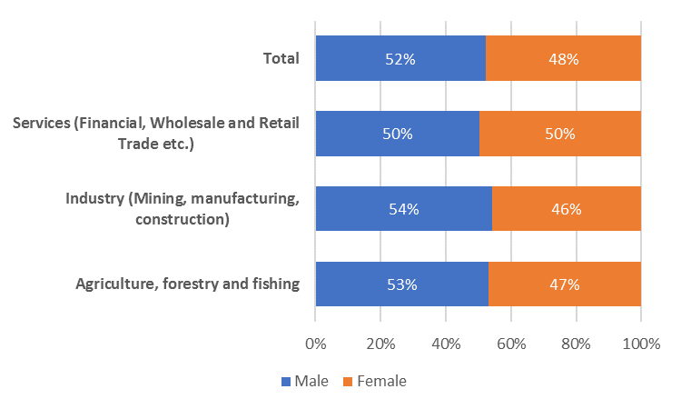
Source: Country X’s Labour Force Survey 2019 data.

Figure 2: Distribution of Employed Population, by Type of Occupation and Sex (%)
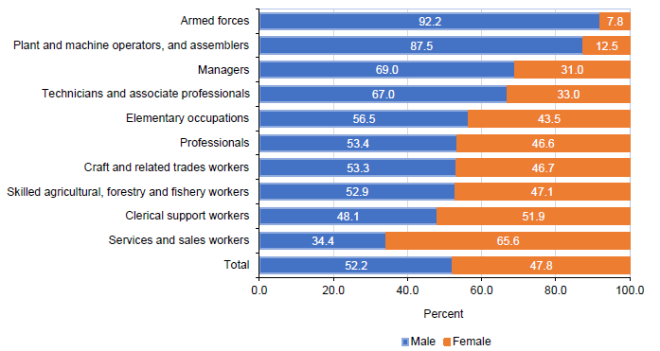
Source: Country X’s Labour Force Survey 2019 data.

Figure 3: Distribution of Employed Population, Type of Occupation by sex within the Agriculture Industry
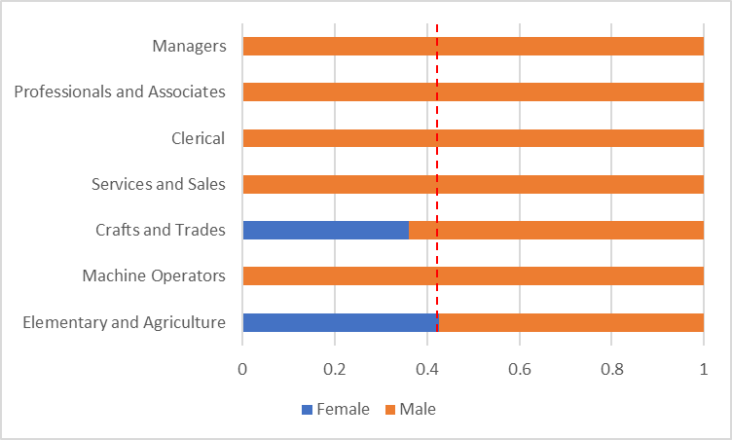
Note: The vertical lines denote share of women in wage employment in the Agriculture industry.
Source: CSES 2014-2016, World Bank Calculations.

Figure 4: Gender Composition of the Individuals Providing the Training*
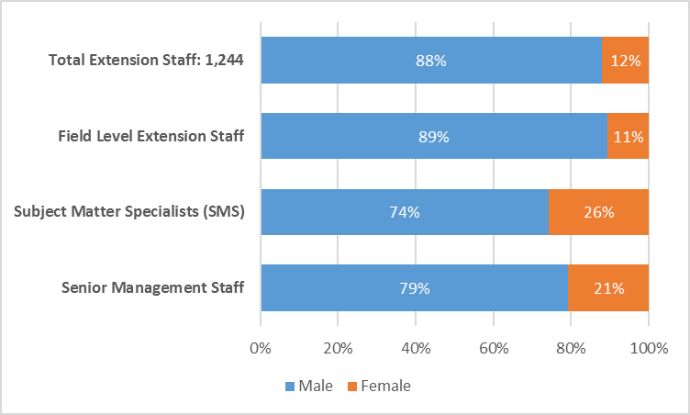
* Human Resources in the Public Extension Service in Country X (Governmental Extension Organization))
Source: IFPRI/FAO/IICA Worldwide Extension Study, 2011

Table 1: Key Gender Goals and Indicators in Country X
- Women’s Economic Empowerment | - Occupation and Industry Segregation:  - Women are over-represented among very low-skilled (and paying) occupations in construction, trades, and agriculture.  - They are particularly under-represented in more skilled jobs – and earn significantly less – in male-dominated sectors including construction and agriculture.  - Gender wage gap:  - In all sectors other than manufacturing, women with identical characteristics and similar occupations still earn significantly less than men.  - External factors explain much of the gender wage gap and occupation/industry segregation, including:  - Domestic responsibilities hinder women’s time commitment to paid employment and economic advancement  - High expectation that women carry the bulk of unpaid household work - women take on most household responsibilities in Country X.  - Work type (certain occupations or industries are viewed as “not appropriate for women) and  - the location of the jobs (for instance, working away from home).
- Increasing Women’s Representation in Leadership and Decision Making | - Women’s participation in management of workplaces lags their labour force participation.  aa  - In majority of occupations, women are under-represented amongst the highest levels of management.  a  - Ownership:  - Only 11.7% of agricultural land is owned by women-headed households.  - Jobs focused on decision making, managing, and leading are seen as traditional male qualities whereas women are traditionally seen as housemakers/child caretakers.
- Promoting access to Education for Women and Girls and Behavioral Change | - Gender stereotypes and attitudes of society and family continue to divide work by sex, which hinders the development of women's roles in modern society.  - Women have been encouraged to embrace skills and work according to gender stereotype and perspectives of society and family, which has not enabled women to select and decide for jobs following market demands nor decision making roles in many industries.
- Ending Gender-based Violence | - One in five women in Country X have experienced physical or sexual violence from an intimate partner, and more than one third of men report having perpetrated partner violence.  - Harmful gender norms are a root cause of gender-based violence (GBV), a human rights violation that negatively affects the mental and physical health of the victim/survivor and contributes to loss of income for women and loss of productivity for workplaces.
- Increasing access to education for girls and promoting a diversification of skills | - Girls are underrepresented in tertiary education and when they do enter tertiary education they are significantly underrepresented in higher paying occupations (e.g., STEM)  - Women have been encouraged to embrace skills and work according to gender stereotype and perspectives of society and family, which has not enabled women to select and decide for jobs following market demands nor decision making roles in many industries.

